GoPay

1. Creating account. Go by link: <https://www.gopay.com/en/>.

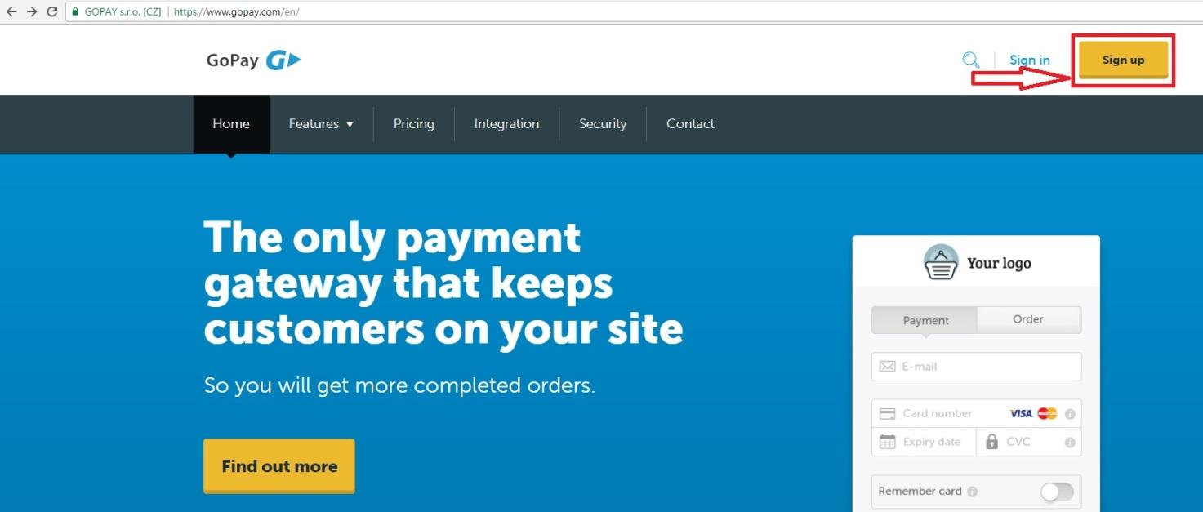

1. For registration enter your e-mail, phone number, password and press Sign up.

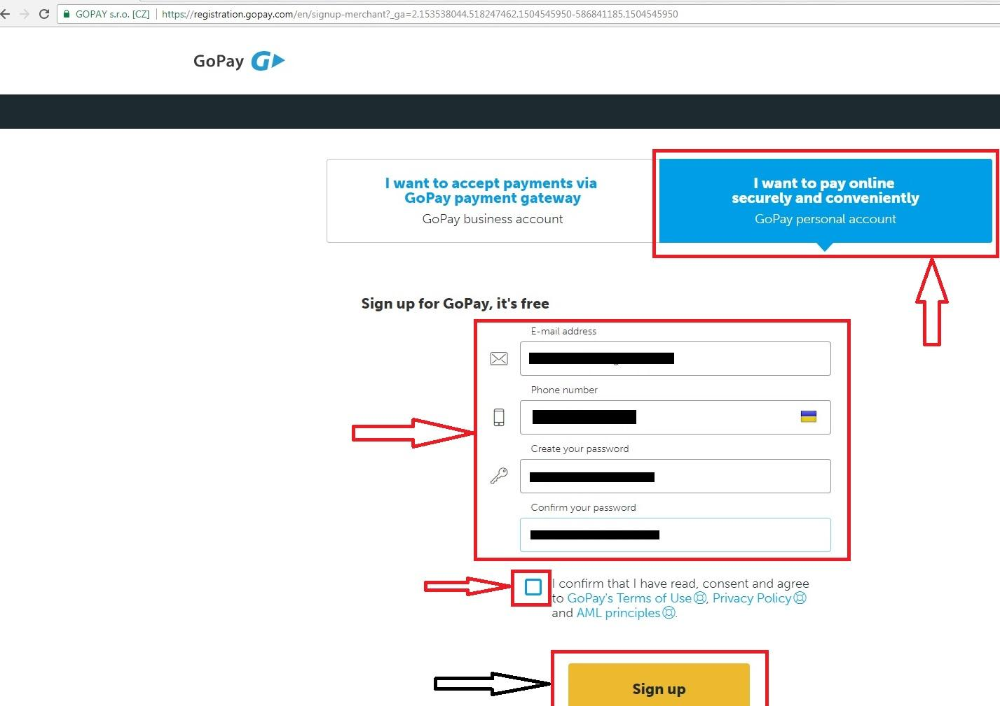

1. Enter your e-mail, password and enter in your account.

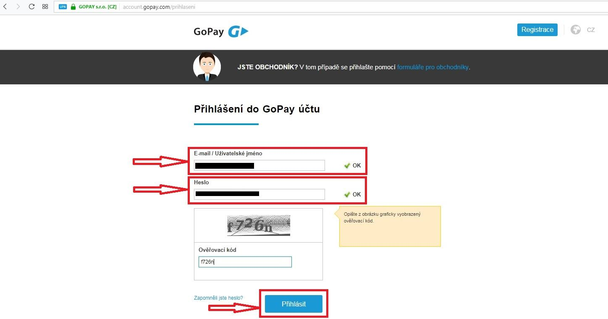

1. Your account.

